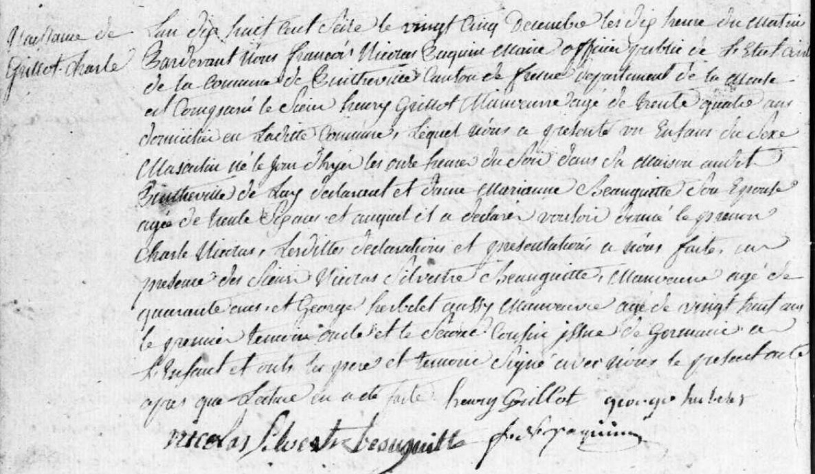
Birth Record of Charles Nicolas Grillot, son of Henry Grillot (brother of Louis Grillot)
Source: archives.meuse.fr
Etat Civil
Pintheville, 1813-1822, Births, Marriages, Deaths
Image 42/113

