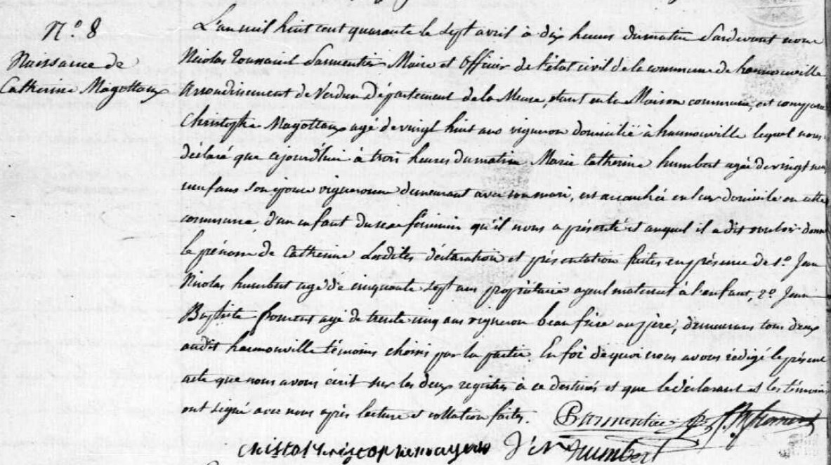
Birth Record of Catherine Magottaux, sister of Jules Francois Magottaux
Source: http://archives.meuse.fr
Etat Civil
Hannonville-sous-les-Cotes
1833-1842 Births Marriages Deaths
Image 345/447

