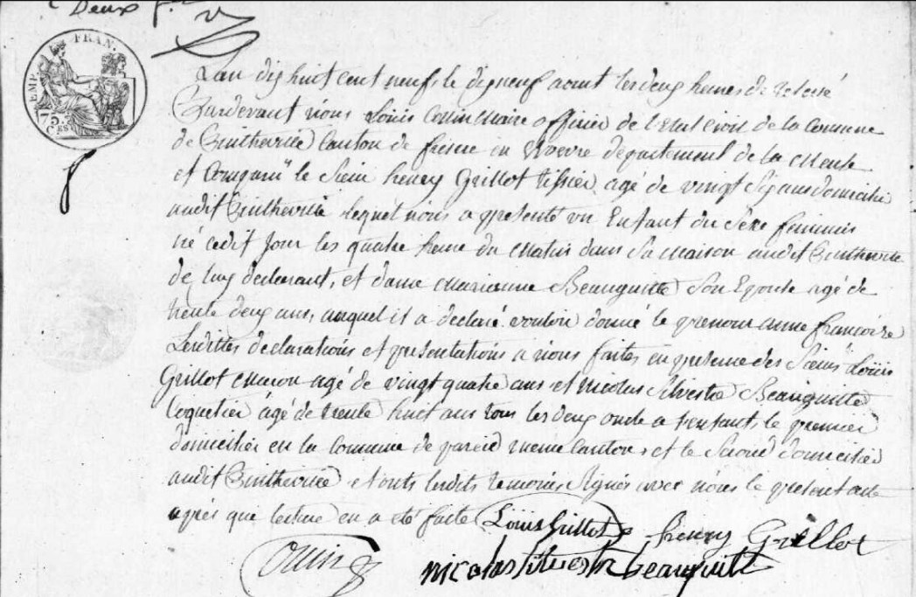
Birth Record of Anne Francoise Grillot, daughter of Henry Grillot (brother of Louis Grillot)
Source: archives.meuse.fr
Etat Civil, Pintheville, 1802-1812, Births, Marriages, Deaths
Image 52/91

