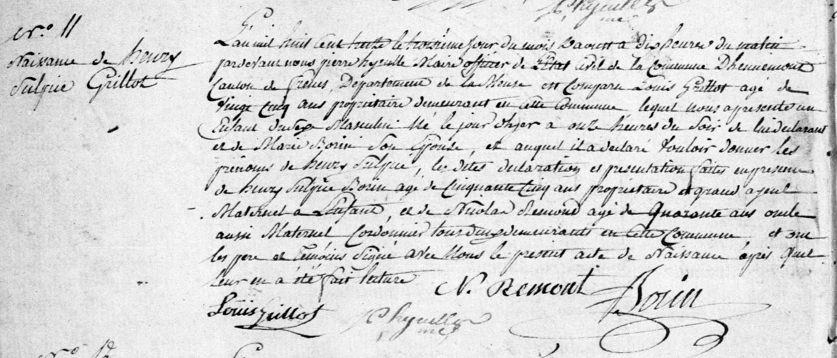
Birth/Baptism Record of Henry Sulpice Grilliot (2 Aug 1813 – 19 Sep 1813), son of Louis Grillot and Marie Born
Source: http://archives.meuse.fr
Etat Civil
Hennemont, 2 E 250 (5)
Births, Marriages, Deaths 1813-1822
Image 10/115

