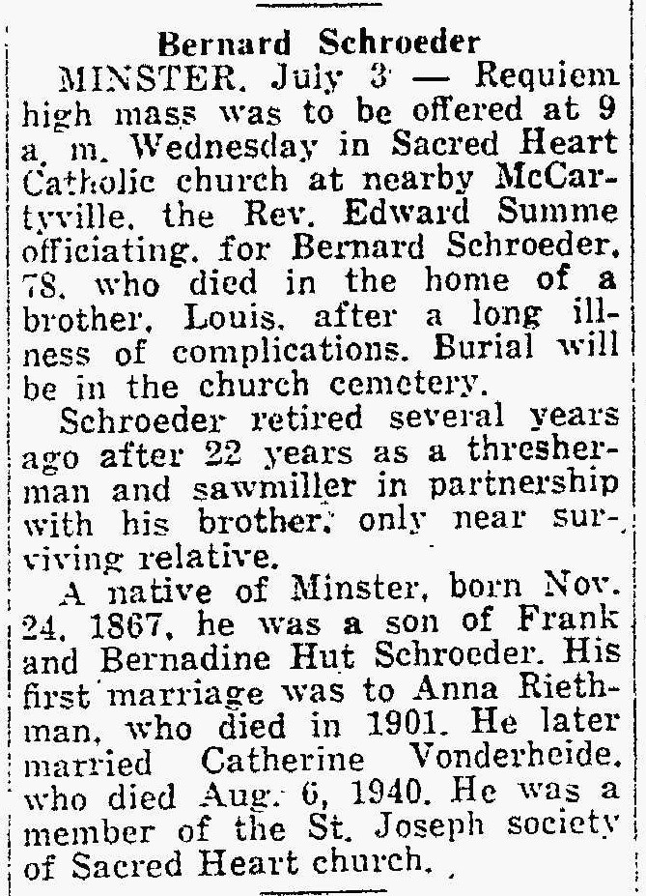
Brother of Joseph Schroeder
The Lima News
3 Jul 1946

