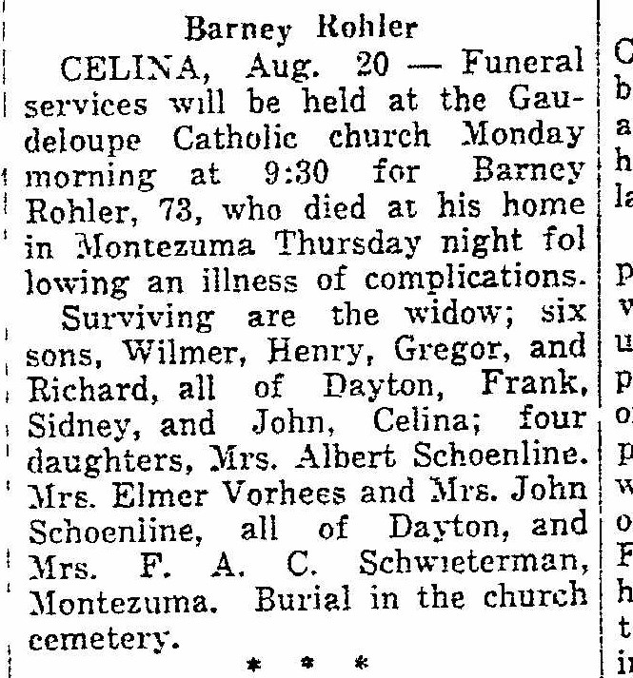
Obituary of Bernard ‘Barney’ Rohler, spouse of Eliz. Watercutter Rohler
The Lima News
21 Aug 1938

