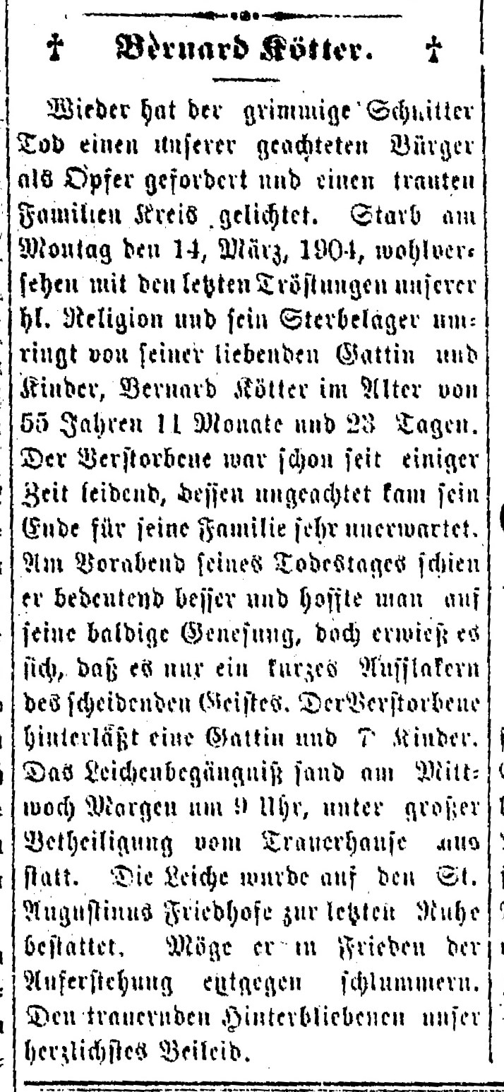
Bernard Koetter, husband of Catherine Bernhold Koetter (sister of Anna Bernhold Schroeder)
The Minster Post
18 Mar 1904
Page 9, column 5

