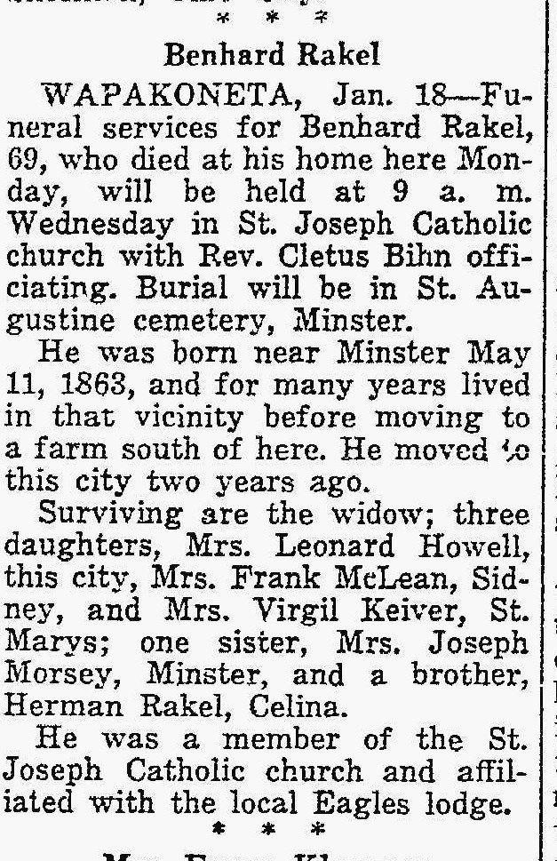
Husband of Katherine Schroeder Rakel, sister of Joseph Schroeder
The Lima News
18 Jan 1938, Page 2

