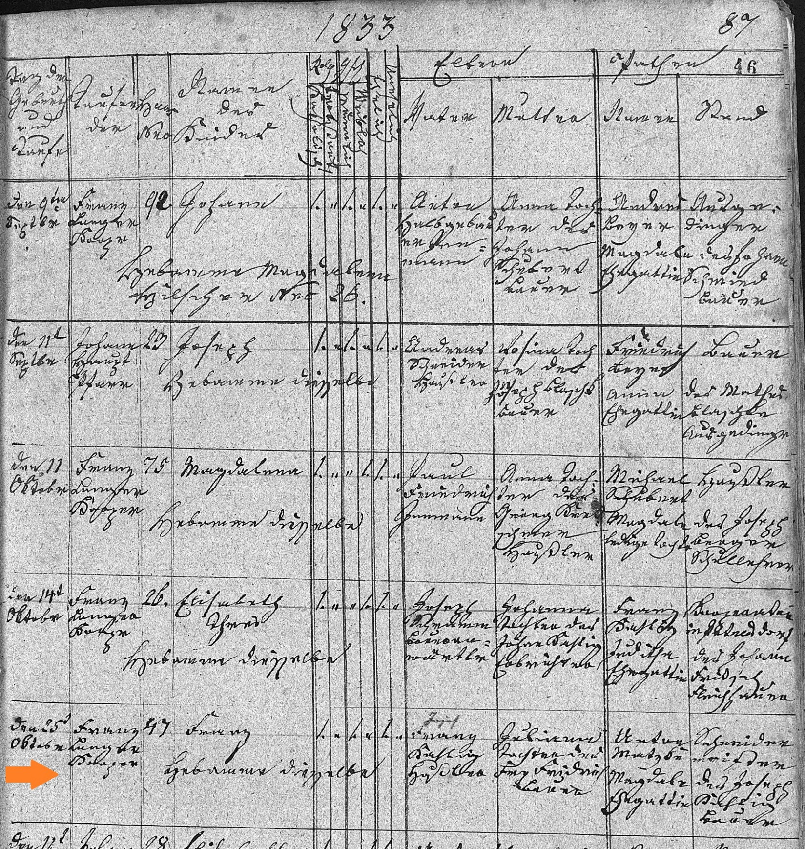
Baptism Record pf Franz Kahlig 25 Oct 1833
FamilySearch.org
Czech Republic Church Books, 1552-1963
Catholic
Novy Jicin > Jesenik nad Odrou > Baptisms 1815-1858 (vol. 2036)

