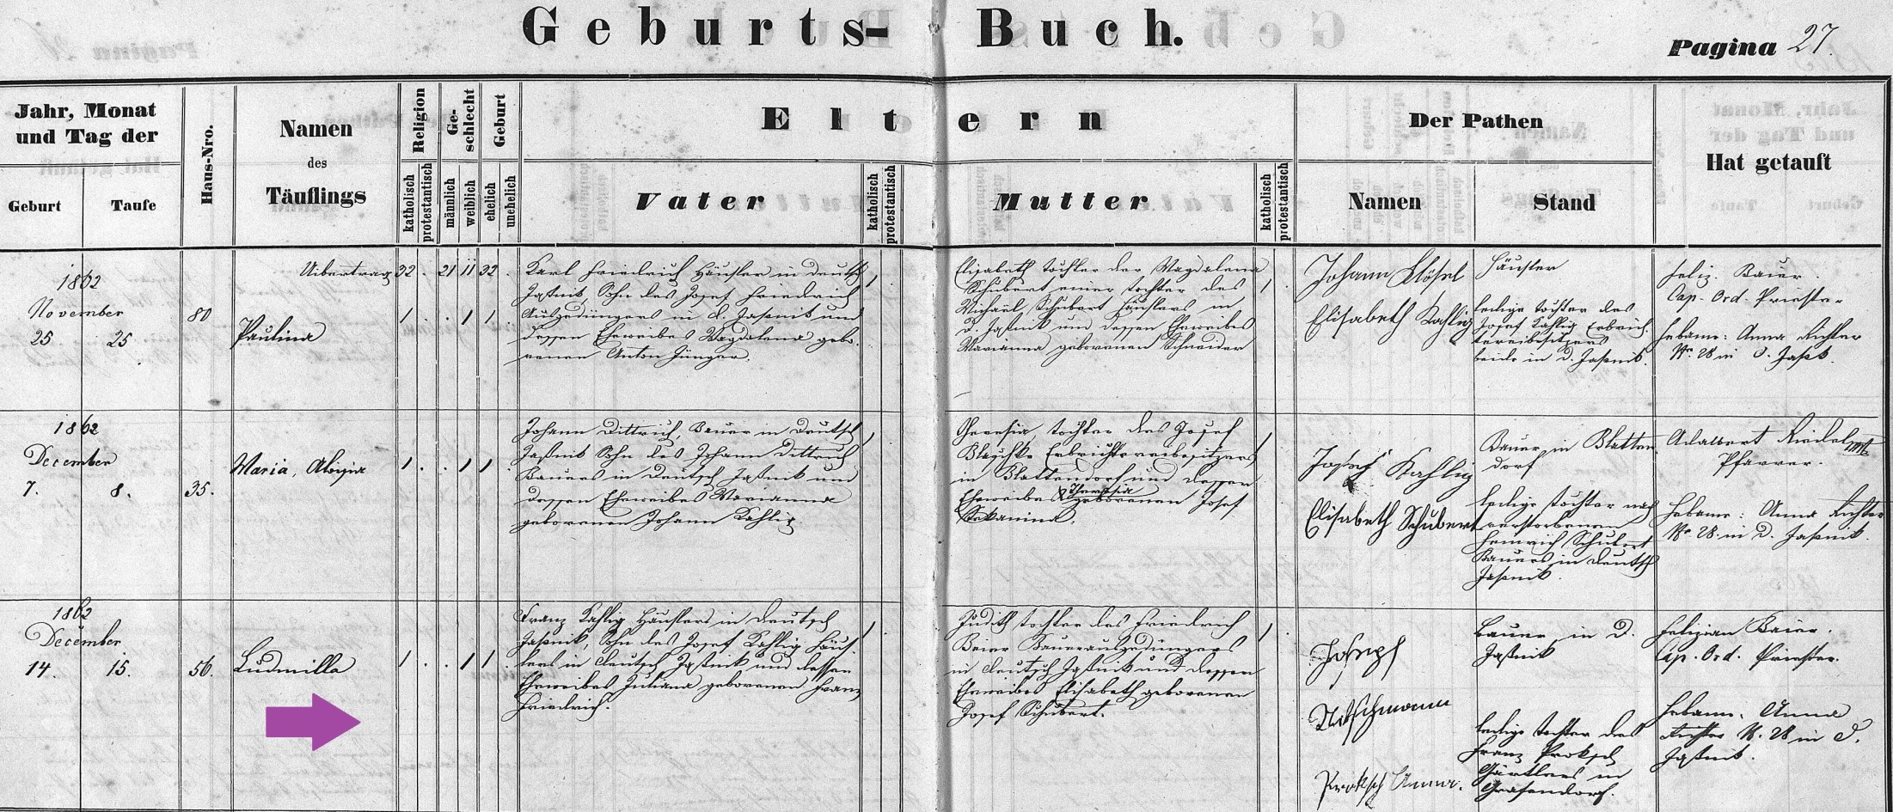
Baptism Record of Ludmilla ‘Amelia’ Kahlig 14 Dec 1862
FamilySearch.org
Czech Republic, Church Books 1552-1963
Catholic
Novy Jicin
Jesenik nad Odrou
Baptisms 1858-1896 (vol 2049)
Image 28/274

