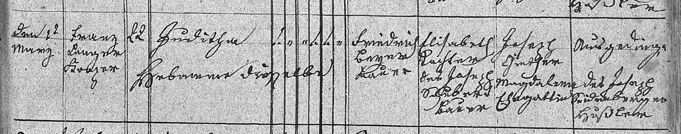
Baptism Record of Juditha Beyer, wife of Franz Kahlig, mother of Louisa Kahlig Braun
33 Mar 1834
FamilySearch.org
Czech Republic Church Books, 1552-1963
Catholic > Novy Jicin > Jesenik nad Odrou
Baptism 1815-1858 (vol. 2036)
Image 49/190

