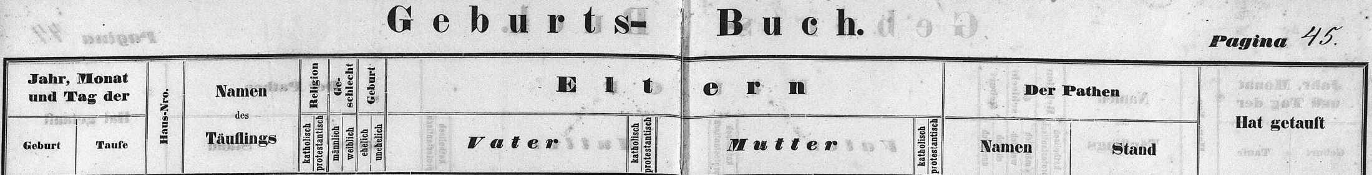

Baptism Record of Joseph Kahlig, son of Franz Kahlig, sister of Louisa Kahlig Braun
FamilySearch.org
Czech Republic Church Books 1552-1963
Catholic
Novy Jicin
Jesenik nad Odrou
Baptisms 1858-1896 (vol 2049)
Image 46/274

