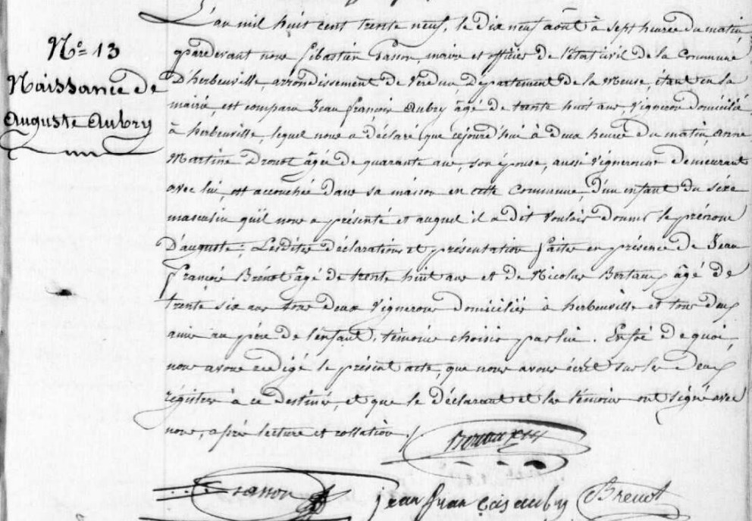
August Aubry Birth Record, brother of Marie Anne Aubry Grilliot
Source: archives.meuse.fr
Etat Civil 1833-1842, Births, Marriages, Deaths Image 280/450

