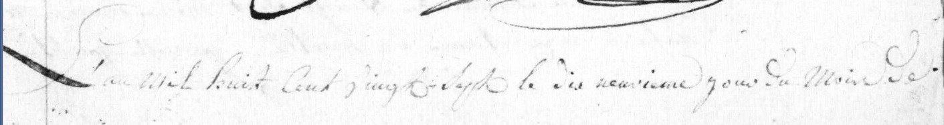
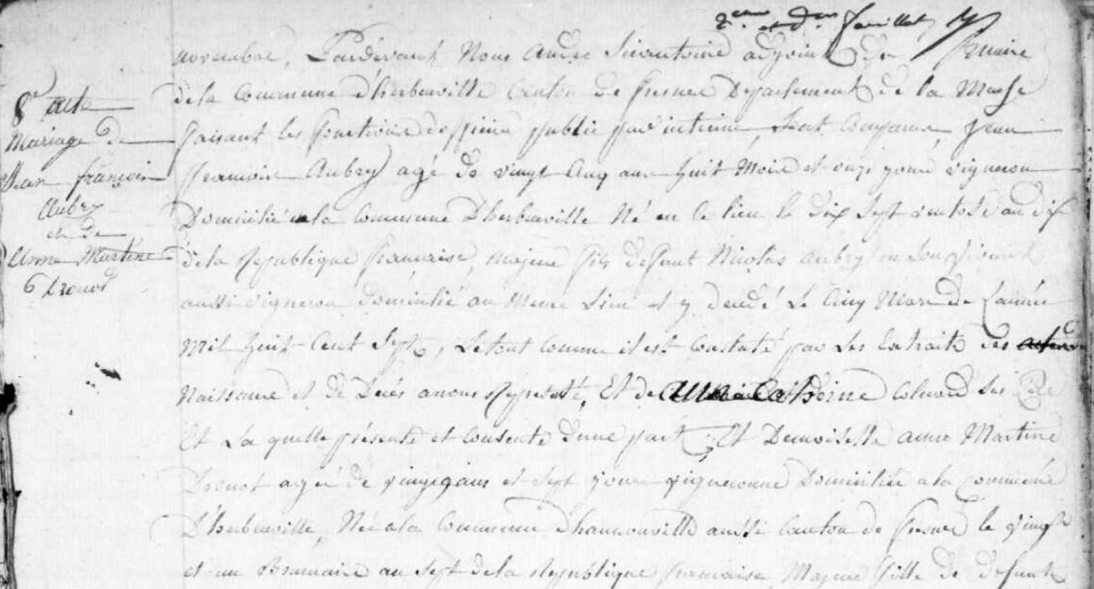
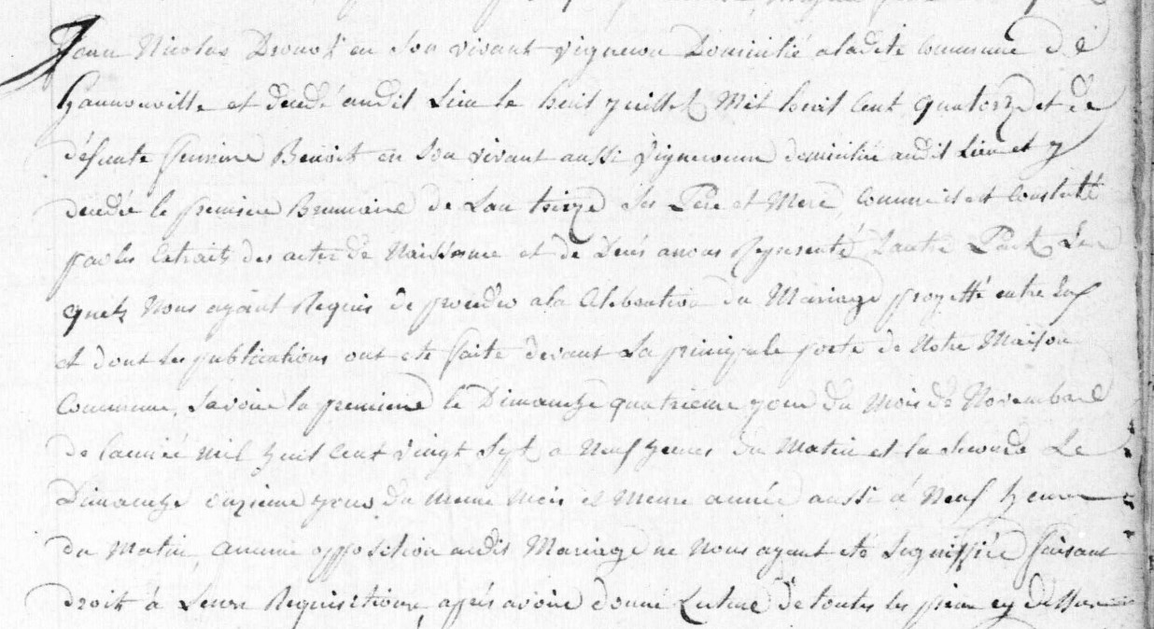
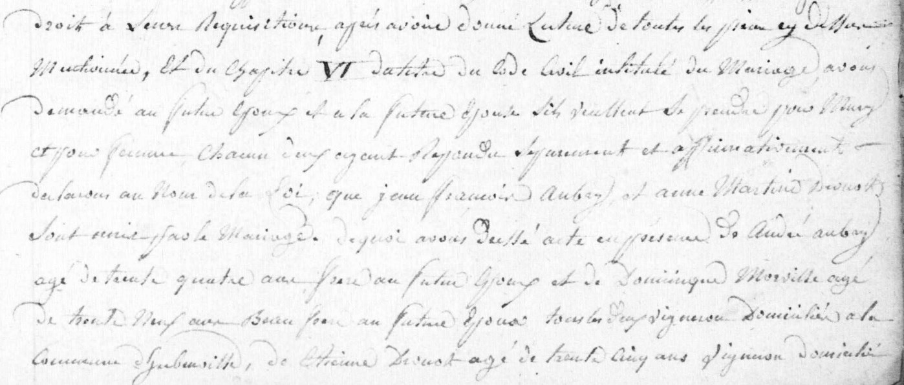
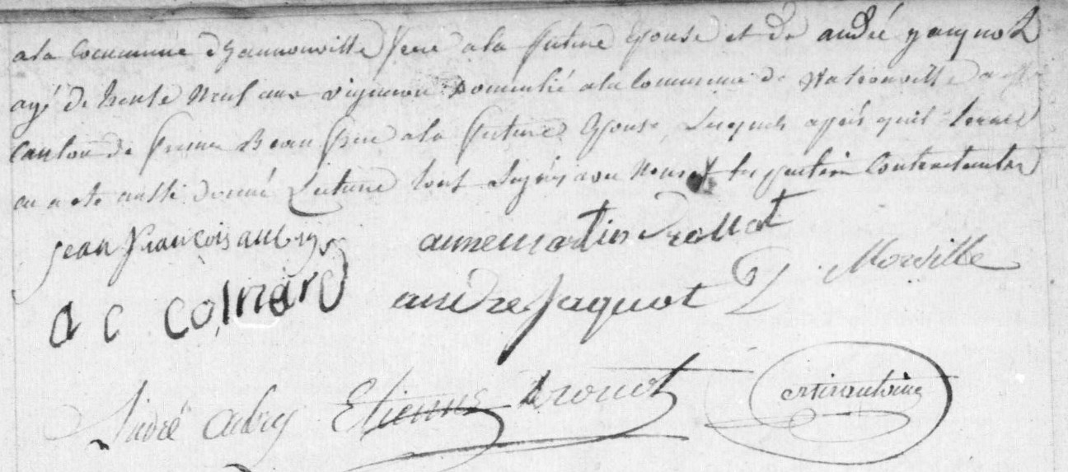
Aubry – Drouot Marriage Record
Source: archives.meuse.fr
Etat Civil
Herbeuville
1823-1832, Births, Marriages, Deats
Images 138-139/353

