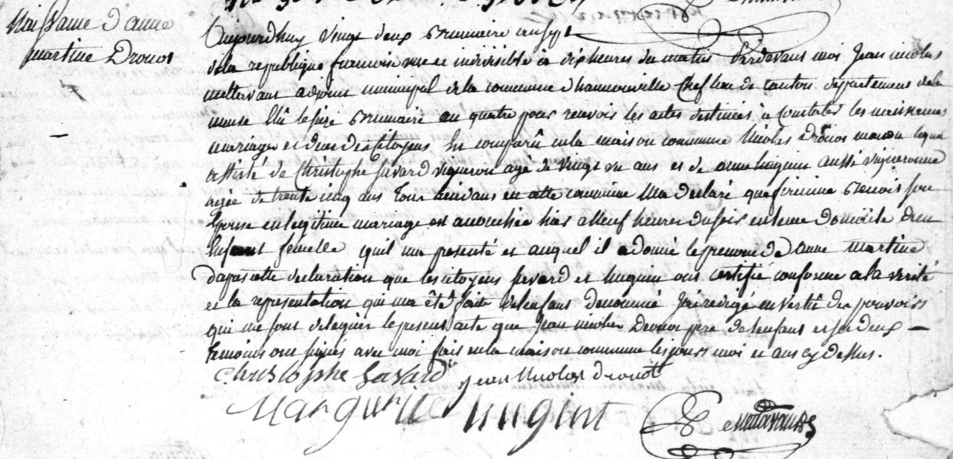
Anne Martine Drouot Birth Record
Source: http://archives.meuse.fr
Hannonville-sous-les-Cotes
Etat Civil
1792-1802 Births, Marriages, Deaths
Image 205/277

