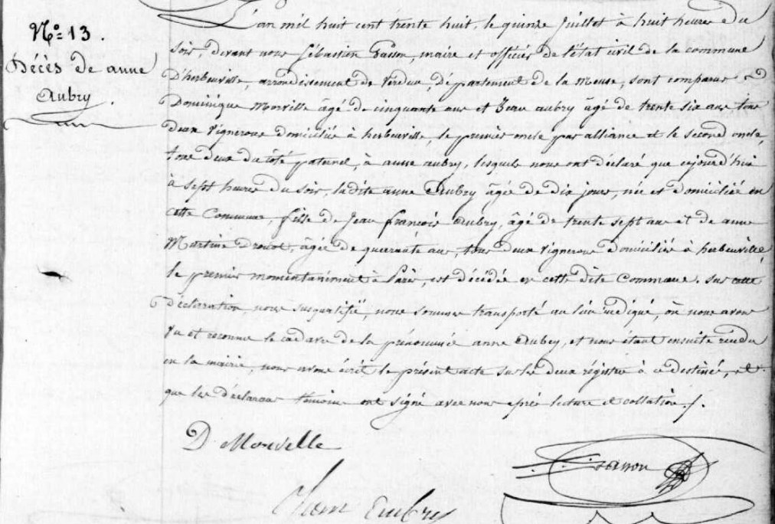
Anne Aubry Death Record, sister of Marie Anne Aubry Grilliot
Source: archives.meuse.fr
Etat Civil 1833-1842, Births, Marriages, Deaths Image 273/450

