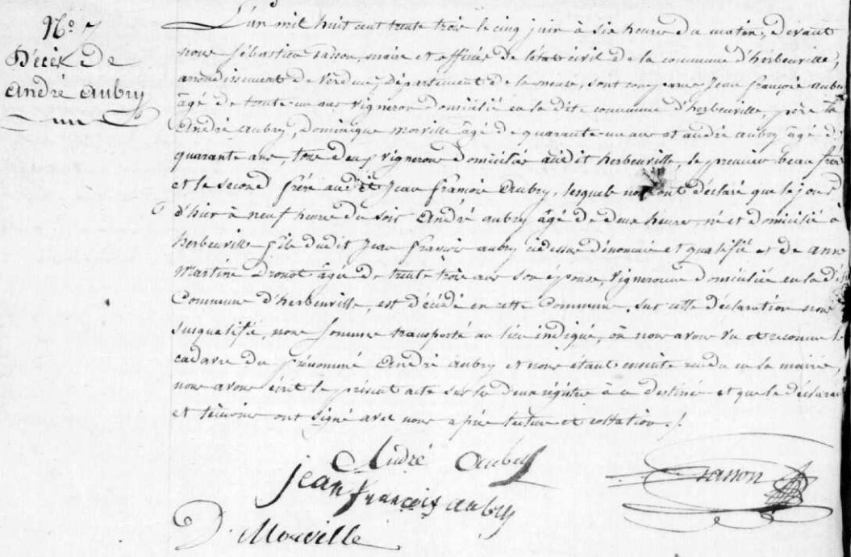
Andre Aubry Death Record, brother of Marie Anne Aubry Grilliot
Source: archives.meuse.fr
Etat Civil
1833-1842, Births, Marriages, Deaths
Image 60/450

