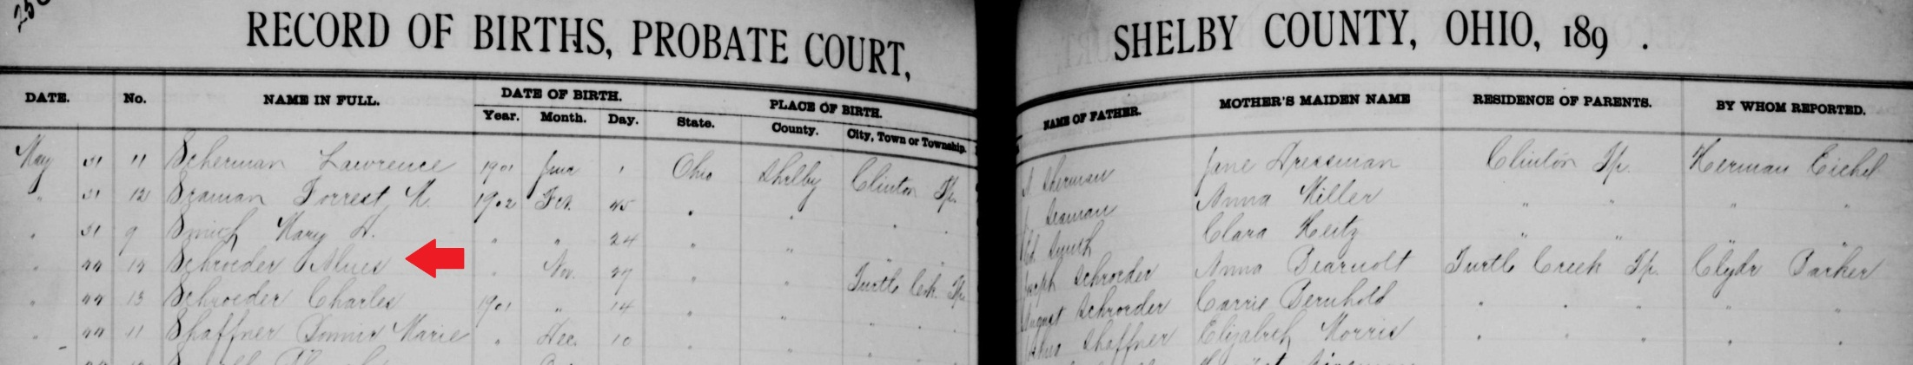
name: | Alues Schroeder
event: | Birth
event date: | 27 Nov 1902
event place: | Turtle Creek Twp., Shelby, Ohio
registration date:
registration place:
gender: | Female
race:
father: | Joseph Schroeder
father's titles & terms:
father's birthplace:
father's age:
mother: | Anna Bearnolt
mother's titles & terms:
mother's birthplace:
mother's age:
additional relatives:
reference number: | v 3 p 256
film number: | 562855
digital folder number: | 004016862
image number: | 00248

Citing this Record
"Ohio, County Births, 1841-2003," index and images, FamilySearch (https://familysearch.org/pal:/MM9.1.1/X6J6-RX1 : accessed 29 Jan 2013), Alues Schroeder, 1902.

