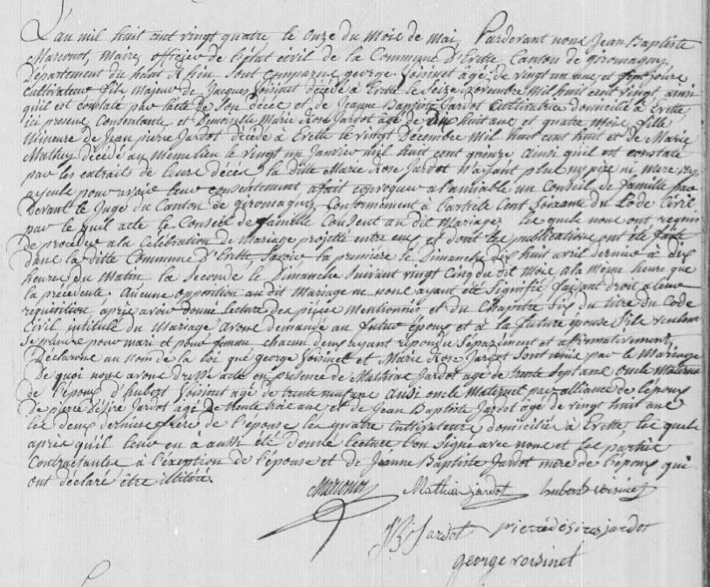
Voisinet-Jardot Civil Marriage Record Source: http://www.archives.cg90.fr/?id=etat_civil
Evette, Births, Deaths, Marriage, 1803-1869 Cote 1 E 42, N.D.M. 1-3 Image 283/783
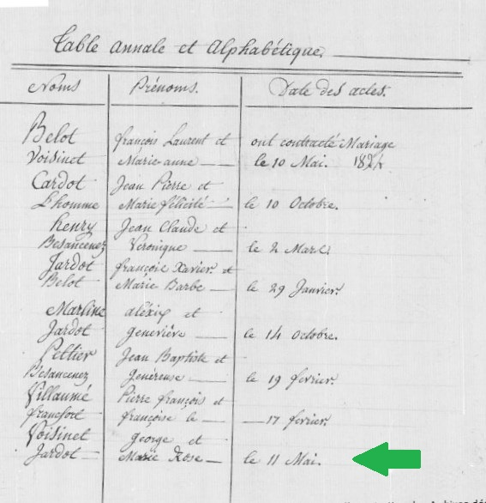
Voisinet-Jardot Civil Marriage Record
Image 285/783

