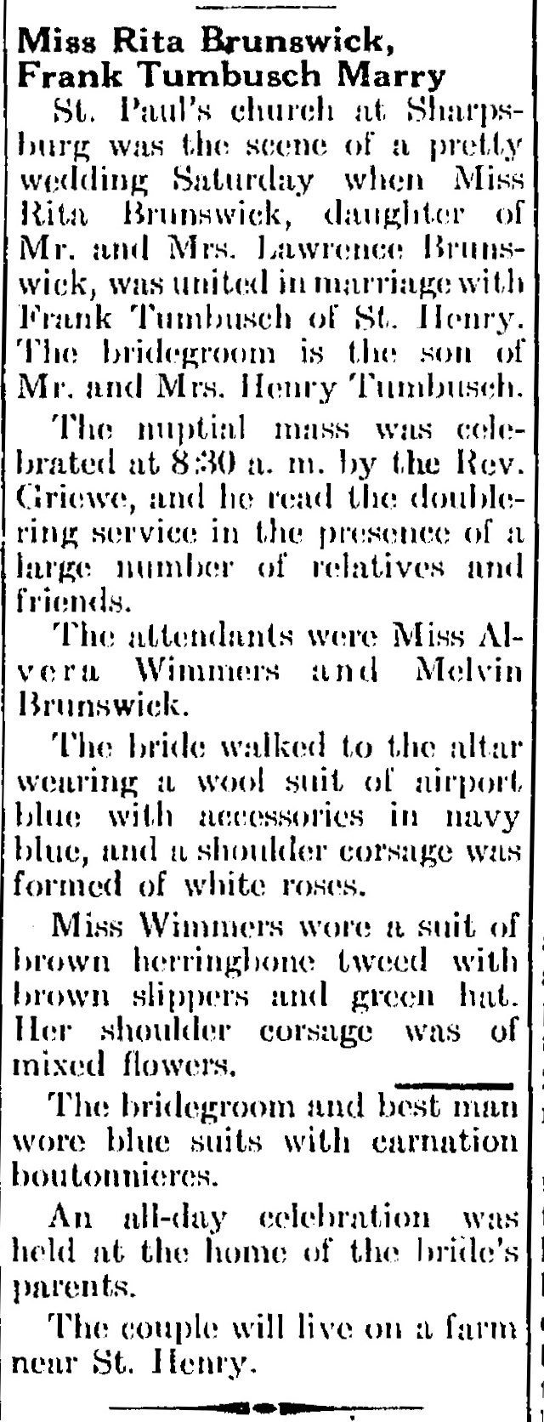

Tumbush-Brunswick Wedding
The Minster Post
27 Nov 1942
Page 4, Column 3

