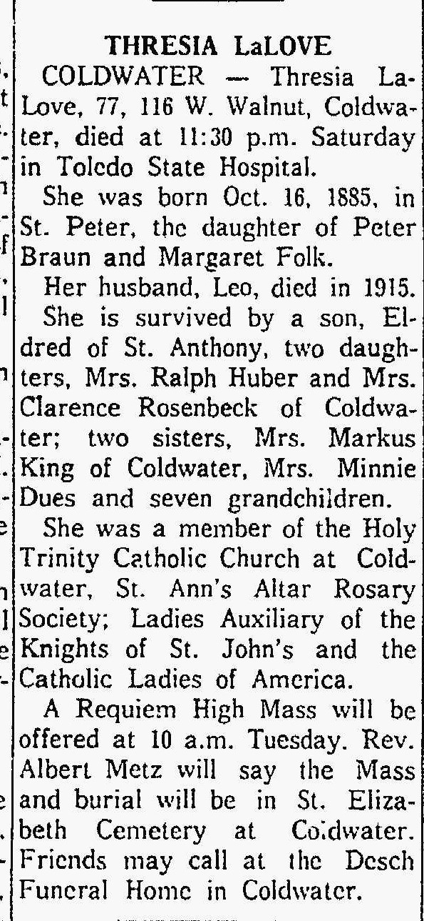
Theresia Braun Laloge, half-sister of John M. Braun
The Lima News
3 Dec 1962

