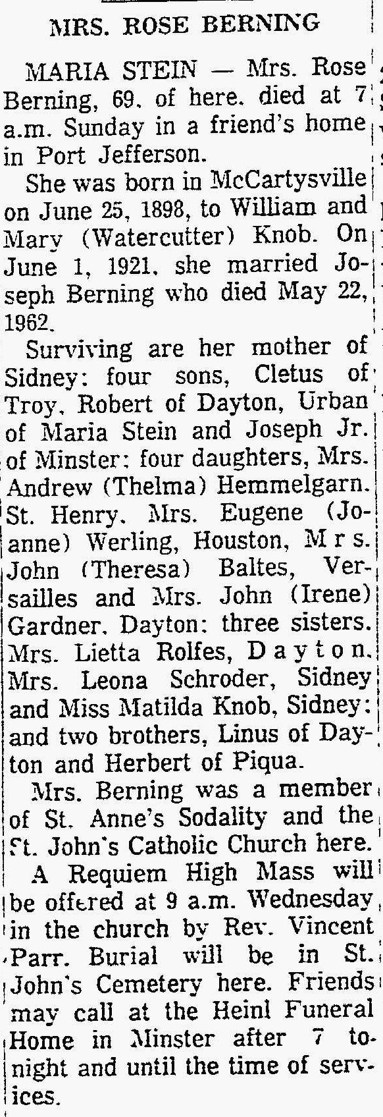
The Lima News
Monday, March 2, 1964

