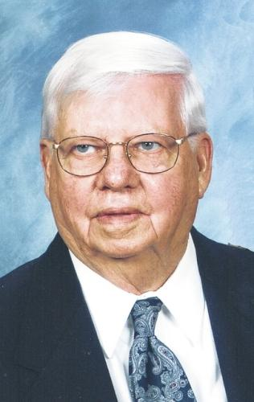
Robert Brunswick(1923 - 2015)
MARIA STEIN — Robert J. Brunswick, age 91, of Maria Stein, Ohio, died at 3:30 p.m. on Wednesday, Jan. 14, 2015, at Mercer County Community Hospital, Coldwater.
He was born on Sept. 5, 1923, in Sharpsburg, Ohio, to the late Lawrence and Justine (Braun) Brunswick. He married Erma Luttmer on Oct. 16, 1948, in St. Rose Catholic Church. She survives in Maria Stein.
He is also survived by children, David and Elaine Brunswick, Celina, Mary Jane Kaylor, Minster, and Dean and Jane Brunswick, Osgood; five grandchildren, Austin and Karissa Kaylor, Jonathan and Michelle Kaylor, Dustin, Cameron and Aaron Brunswick; great-grandson, Carson; brothers and sister, Dr. Wilferd and Verna Brunswick, Beverly Hills, Florida, Art and Dorothy Brunswick, Beavercreek, Bea Flaherty, Des Moines, Iowa; sister-in-law, Madonna Brunswick, Coldwater; in-laws: Leonard Luttmer, Yorkshire, Alfred and Pauline Luttmer, St. Henry, Norma Stammen, St. Henry and numerous nieces and nephews.
He was preceded in death by grandchildren, Meredith and Matthew Brunswick, brothers and sisters, Melvin and Mildred Brunswick, Richard and Rita Brunswick, John Brunswick, Rita and Frank Tumbush, Wilma Brunswick, Mary Catherine Brunswick, Ruth and Ed Goubeaux, in-laws, Lawrence and Mercedes Poeppelman, Wilbert Luttmer, Bernard and Marie Luttmer, Werner Stammen and Virgil and Norma Arkenberg.
He was a member of St. John the Baptist Catholic Church and the Men's Sodality of the church. He was a veteran of the U.S.Army during World War II. He was a member of Maria Stein American Legion, Chickasaw VFW, and Catholic Foresters.
Bob retired from Weaver Brothers Eggs after 60 years of service, and also worked for Larger Brothers. Bob loved his family, his work and a good game of cards.
Mass of Christian Burial will be held 10:30 a.m. on Saturday, Jan. 17, 2015, at St. John the Baptist Catholic Church, Maria Stein, with the Rev. Tom Brenberger celebrant. Burial with full military honors will take place in St. John Cemetery.
Friends may call at the Hogenkamp Funeral Home, Minster, from 3 to 7 p.m. on Friday, Jan. 16, 2015, and from 9 to 10 a.m. on Saturday, Jan. 17, 2015.
Memorial contributions may be made to the Mercer County Aktion Club in honor of Bob's granddaughter, Meredith.
""`Condolences may be made at www.hogenkampfh.com.

Funeral Home
Hogenkamp Sons, Inc.
61 S. HANOVER ST. Minster, OH 45865-1233
(419) 628-2341
Published in Sidney Daily News from Jan. 15 to Jan. 16, 2015

Brother of Rita Brunswick Tumbush
Source: http://www.legacy.com/obituaries/sidneydailynews/obituary-print.aspx?n=robert-brunswick&pid=173862555

