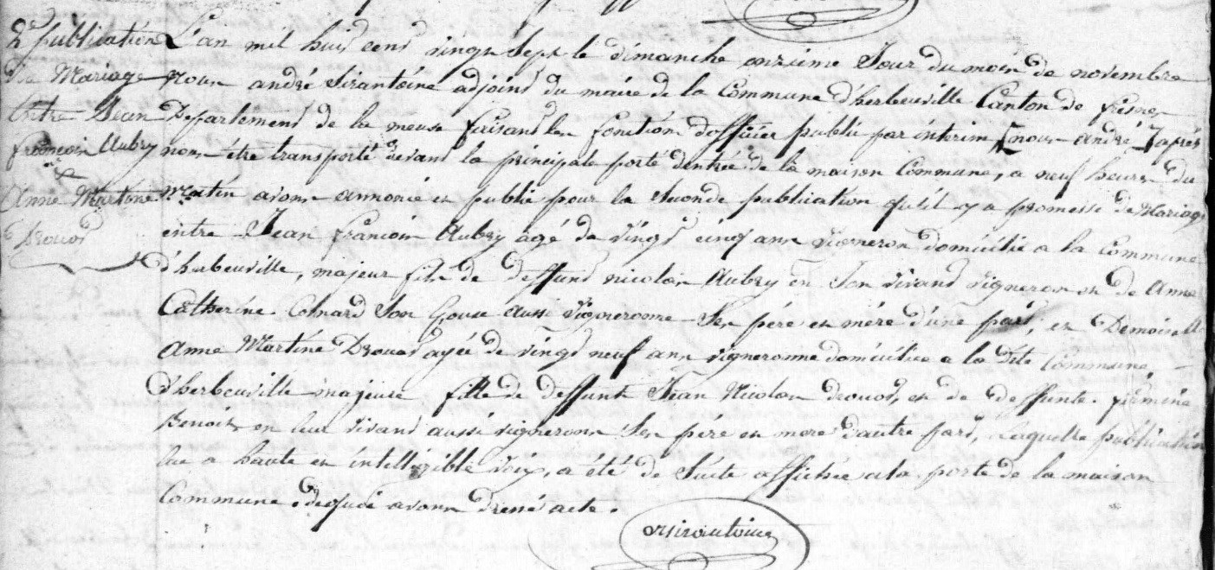

Publication of Marriage Banns (11 Nov 1827)
Jean Francois Aubry and Anne Martine Drouot
Source: archives.meuse.fr
Herbeuville
Etat Civil 1823-1832, Births, Marriages, Deaths
Image 104/353

