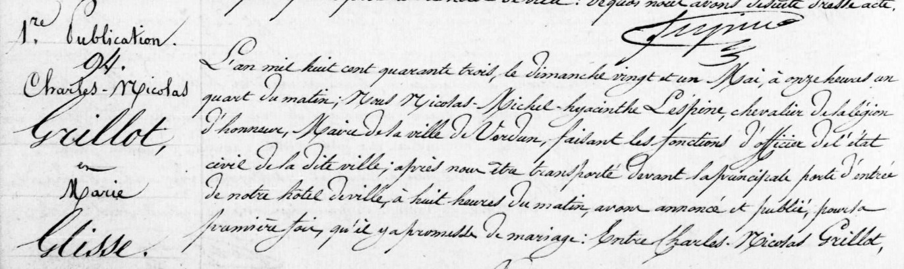
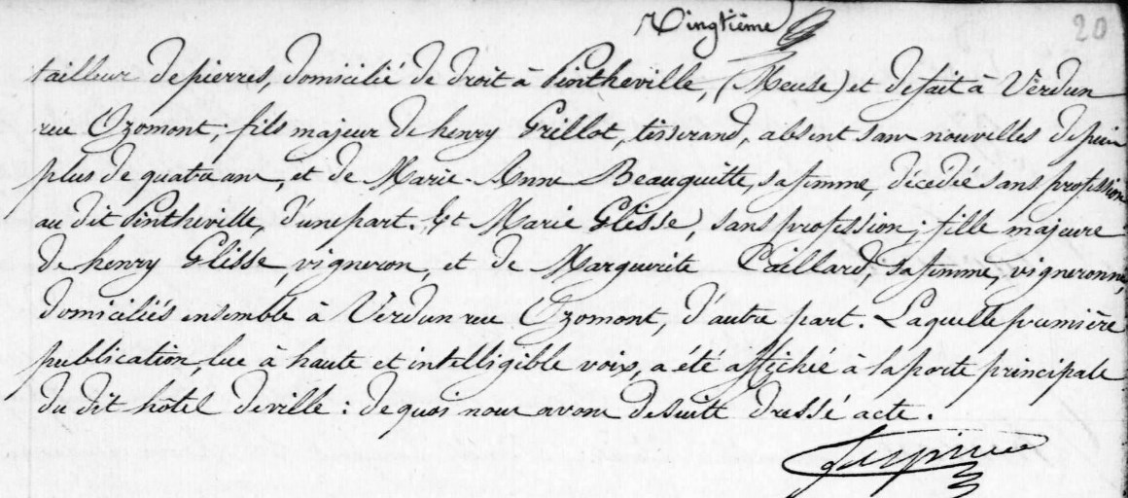
Publication of Marriage Banns in Verdun, France for Charles Nicolas Grillot, son of Henry Grillot (brother of Louis Grillot)
Source: archives.meuse.fr
Verdun, 1843-1843 Births, Marriages, Deaths
Image 120/512

