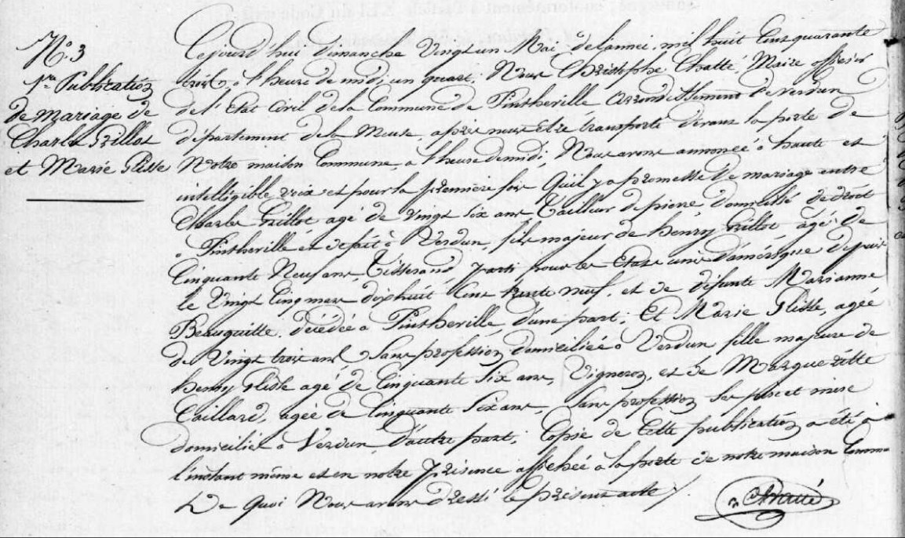
Publication of Marriage Banns for Charles Grillot, son of Henry Grillot (brother of Louis Grillot)
Source: archives.meuse.fr
Etat Civil
Pintheville, 1843-1852 Births, Marriages, Deaths
Image 11/154

