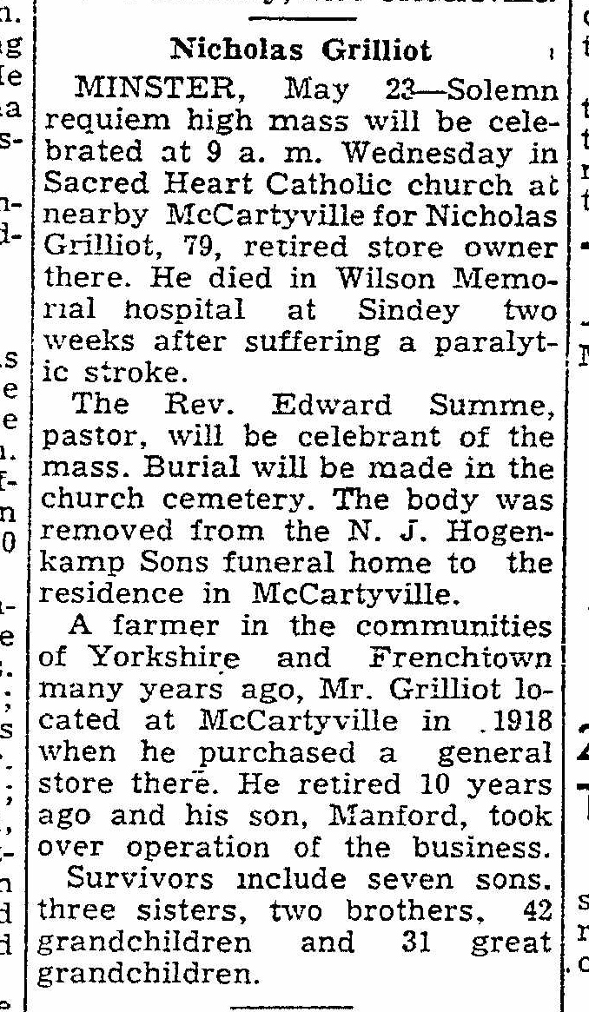
Obituary of Nicholas Grilliot
The Lima News
23 May 1950
Page 2, Column 6

