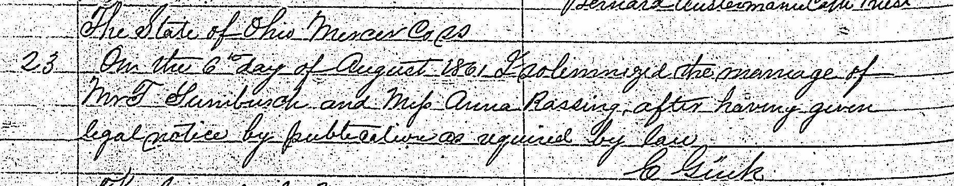
Marriage Record Theodor Tumbusch and Anna Rasing
Source:
FamilySearch.org
Ohio, County Marriages, 1789-1994
Mercer County
Marriage Records 1862-1870 vol E
Image 20/55

