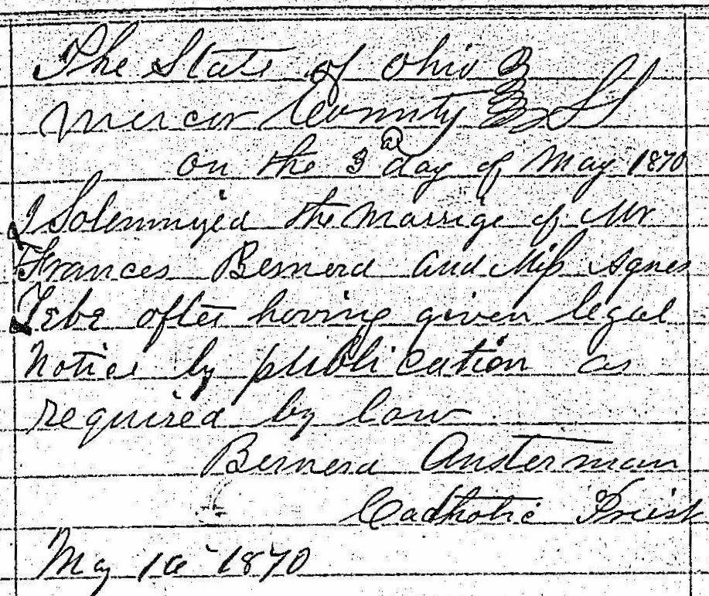
Marriage Record of Francis Bernard, brother of Maria Magdalena Bernard Rolfes
Source: FamilySearch.org
Ohio, County Marriages, 1789-1994
Mercer County
Marriage Records 1862-1870 vol E
Image 53/55

