Marlene Schwarz(1935 - 2017)
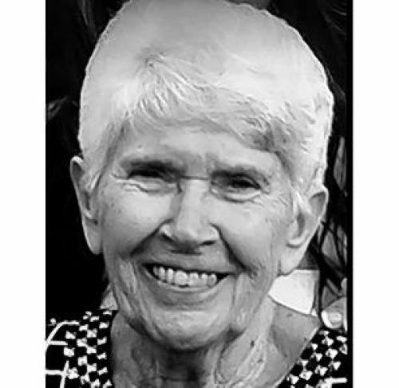
SCHWARZ, Marlene M. Of Fairfield, OH, age 81, died of a rare aggressive cancer on January 28, 2017 at Doverwood Village surrounded by her treasured family. She is survived by her loving husband and partner of 59 years, Joseph W. Schwarz; devoted son, Joseph B. Schwarz "JoJo"; and three cherished grandchildren, Sonny, Rachel and Zack Schwarz. Marlene was a teacher when she met and married Joe and then worked side by side with her husband to successfully grow their business. Marlene leaves sisters and brothers from her hometown of McCartyville, OH, sisters from Mt. Heathy, OH and Orlando, FL, and a brother from Stockton, CA. Marlene leaves many nieces and nephews along with loving friends from Fairfield. Memorial contributions can be made to Sisters of Charity of Cincinnati. Visitation will be held at Sacred Heart Church, 400 Nilles Rd., Fairfield, 45014 on Wednesday February 1, 2017, 9:00 a.m. until noon with Mass of Christian Burial immediately following. A celebration of life will follow the Mass at Tori's Station 74 Donald Drive, Fairfield, 45014. Condolences may be offered at www.avancefuneralhome.com

Funeral Home
Avance Funeral Home & Crematory
4976 Winton Road Fairfield, OH 45014
(513) 829-6257
Published in Dayton Daily News on Jan. 31, 2017

