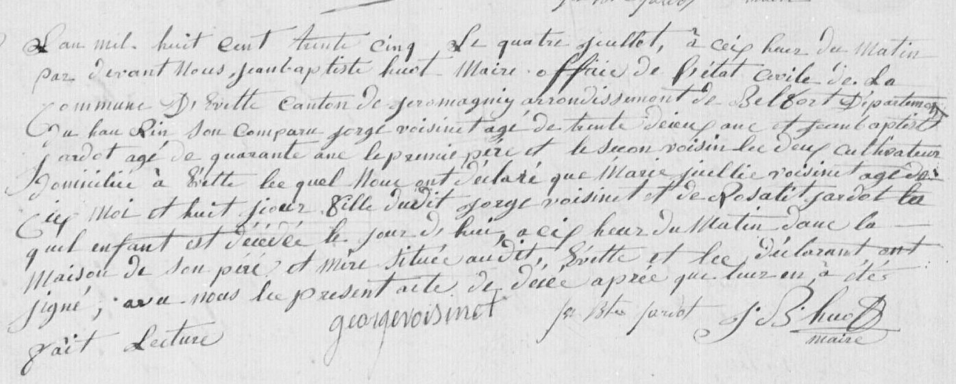
Marie Julie Voisinet, sister of Marie Celestine Voisinet
Civil Death Record (1835)
Source: http://www.archives.cg90.fr/?id=etat_civil
Evette, Births, Deaths, Marriages 1803-1869
Cote 1 E 42, N.D.M. 1-3
Image 357/783

