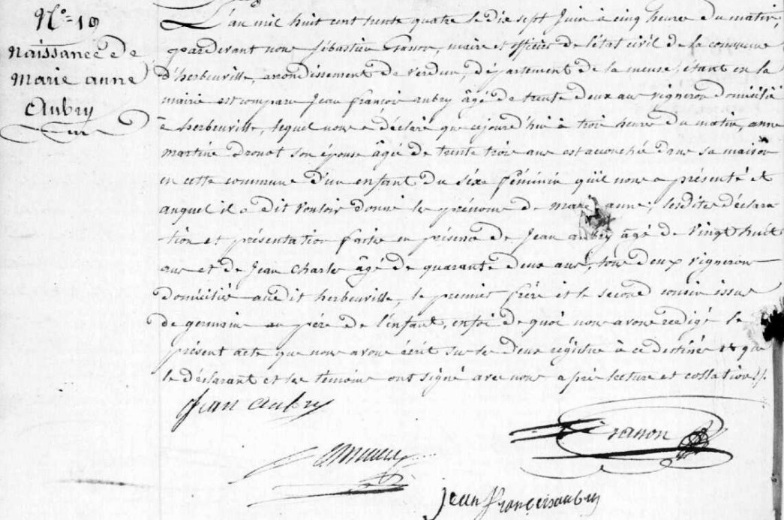
Marie Anne Aubry (Grilliot) Birth Record
Source: archives.meuse.fr
Etat Civil 1833-1842, Births, Marriages, Deaths
Image 69/450

