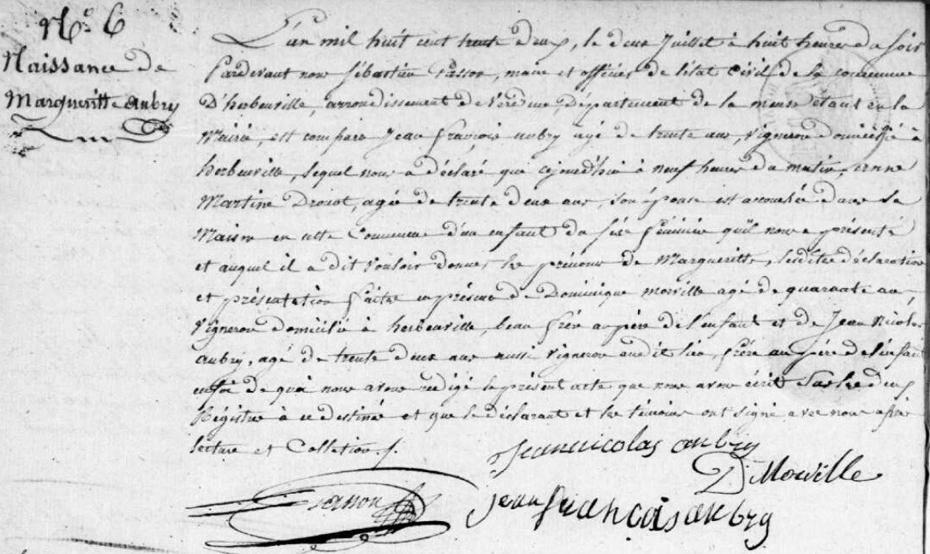
Birth Record of Marguerite Aubry, sister of Marie Anne Aubry Grilliot
Source: archives.meuse.fr
Etat Civil
1823-1832, Births, Marriages, Deaths
Image 308/353

