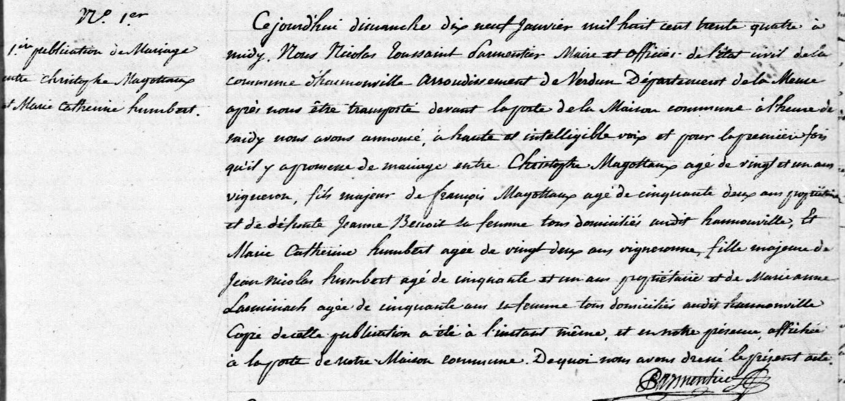
Magottaux-Humbert First Wedding Banns
19 Jan 1834
Source: http://archives.meuse.fr
Etat Civil
Hannonville-sous-les-Cotes
1833-1842, Births Marriages Deaths
Image 93/447

