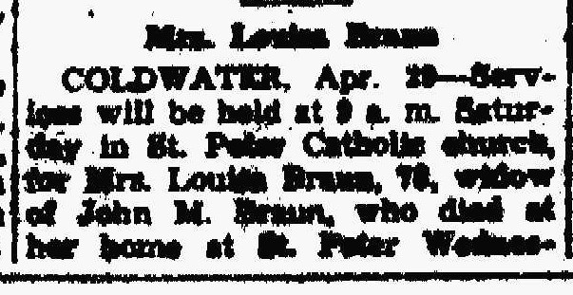
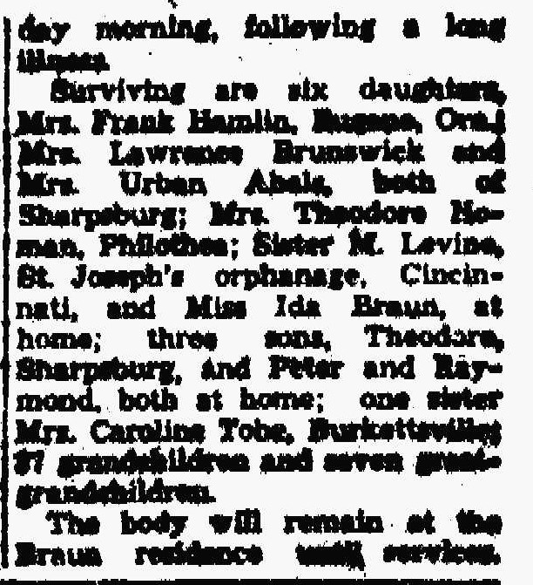
Louisa Kahlig Braun Obituary
The Lima News
29 Apr 1948

