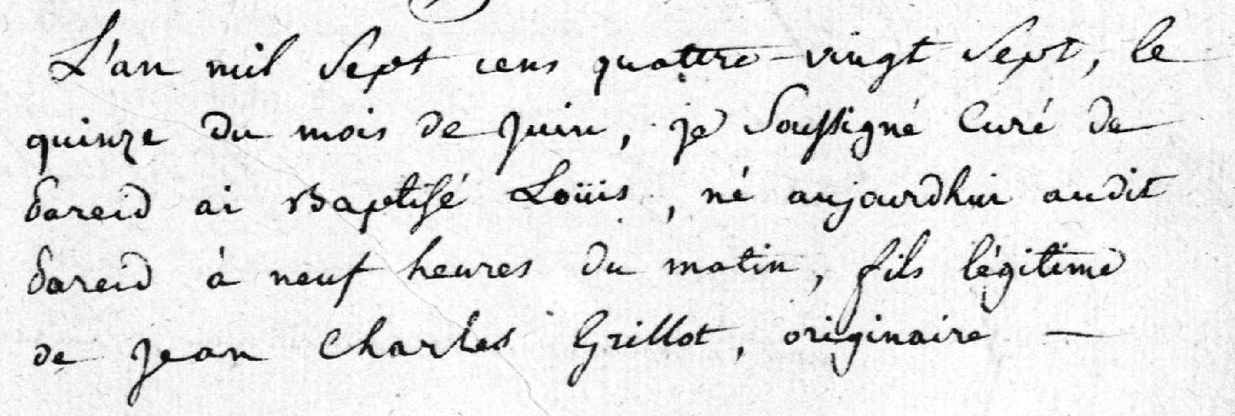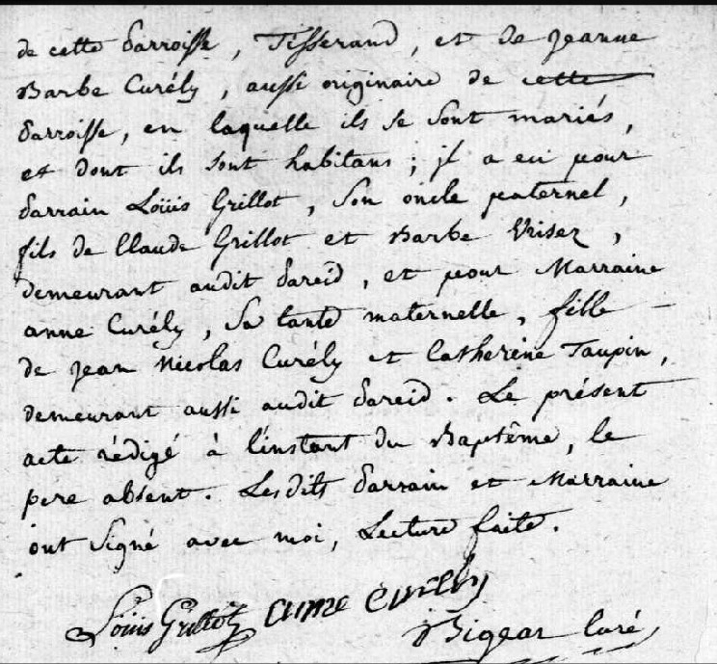
Louis Grillot Birth Record, Pareid, France http://archives.meuse.fr Etat Civil 1765-1791 Images 218-219/285

