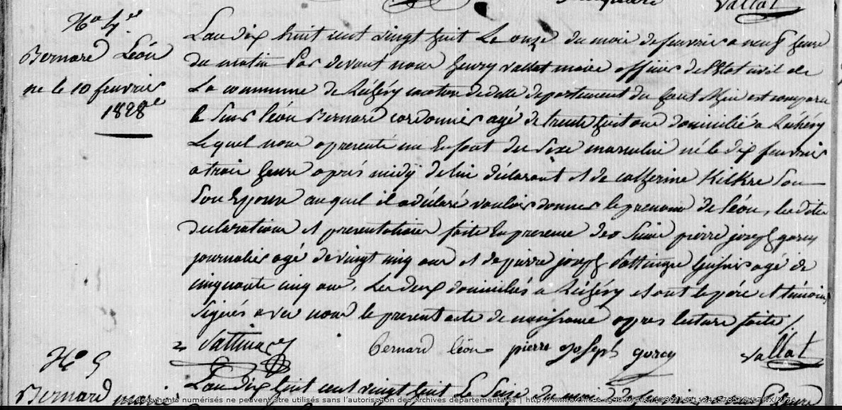
Birth Record of Leon Bernard, son of Leon Bernard, brother of Joseph Bernard
Territoire de Belfort Archives, Rechesy
Etat Civil 1803-1829 1E 81 N.D.M. 1-2
Source: http://www.archives.cg90.fr/ark:/12997/a011341578574HL7fvX/2/1
Image 74/221

