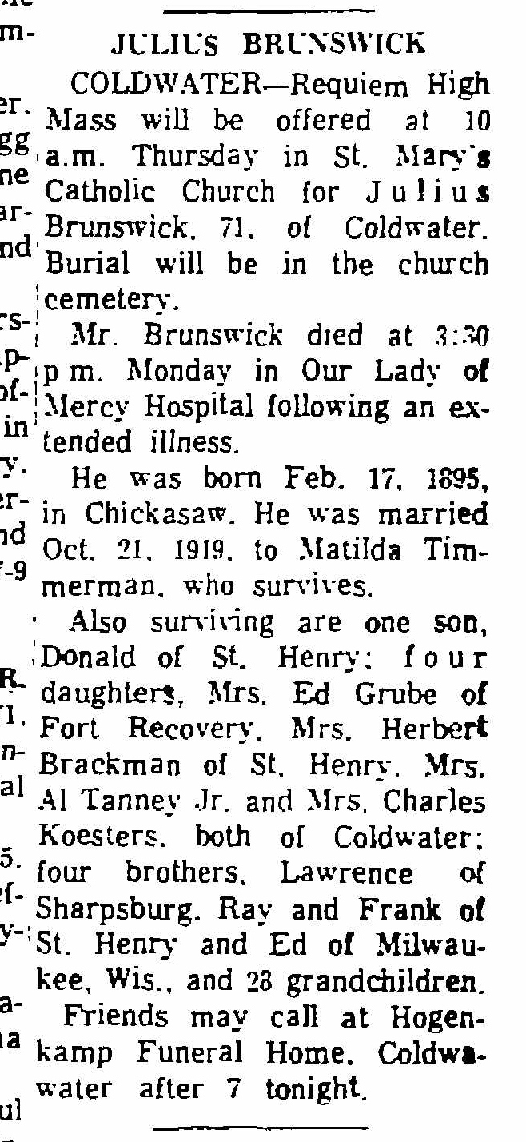
Obituary of Julius Brunswick, brother of Lawrence Brunswick
The Lima News
24 Jan 1967
Page A-4, column 8

