Joseph J. Bulcher, "Ohio, County Marriages, 1789-1994"
Name: | Joseph J. Bulcher
Titles and Terms:
Event Type: | Marriage
Event Date: | 08 Oct 1878
Event Place: | Darke, Ohio, United States
Event Place (Original):
Age:
Birth Year (Estimated):
Birth Date:
Birthplace:
Father's Name:
Father's Titles and Terms:
Mother's Name:
Mother's Titles and Terms:
Spouse's Name: | Adaline M. Poly
Spouse's Titles and Terms:
Spouse's Age:
Spouse's Birth Year (Estimated):
Spouse's Birthplace:
Spouse's Father's Name:
Spouse's Father's Titles and Terms:
Spouse's Mother's Name:
Spouse's Mother's Titles and Terms:
Reference ID: | v e p 84 n 251
GS Film number: | 1030773
Digital Folder Number: | 004017445
Image Number: | 00078

Citing this Record
"Ohio, County Marriages, 1789-1994," index and images, FamilySearch (https://familysearch.org/pal:/MM9.1.1/X8KN-DTL : accessed 27 Mar 2013), Joseph J. Bulcher and Adaline M. Poly, 1878.
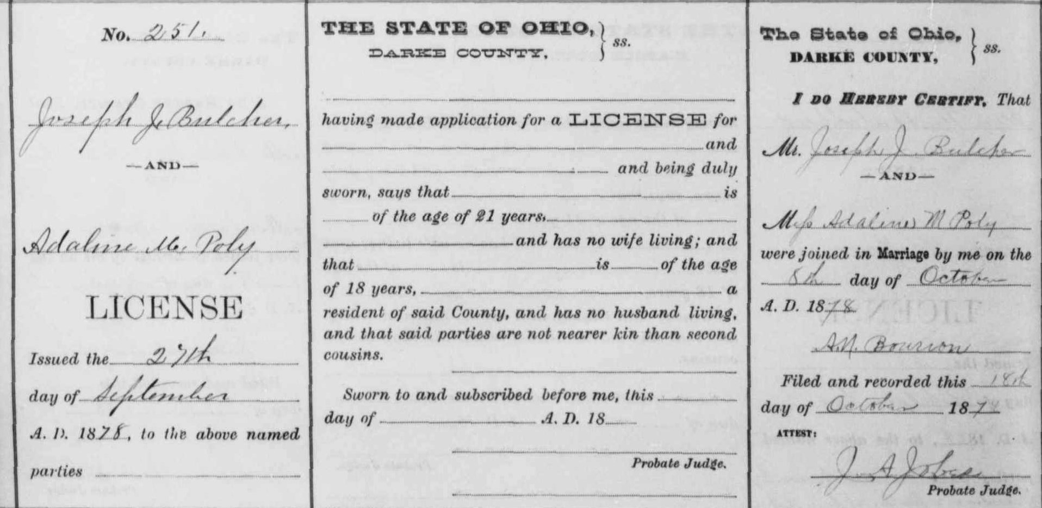
Brother of Mary Rosa Bulcher Magoto

