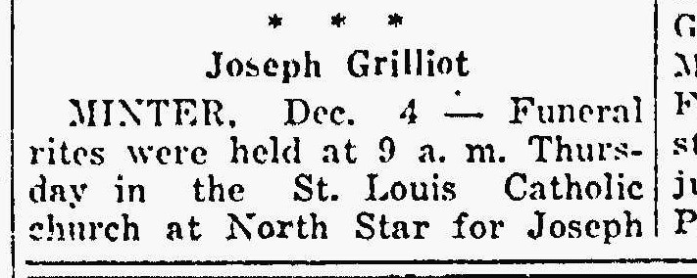
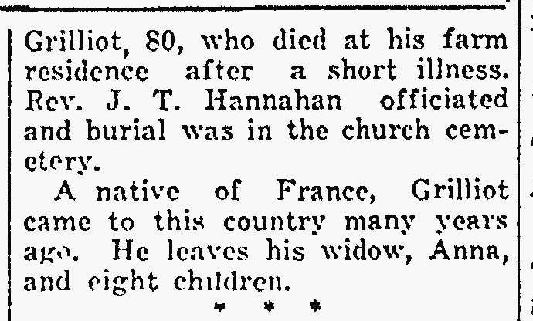
Joseph Grilliot, brother of Nicholas Grilliot
The Lima News
4 Dec 1941
Page 4

