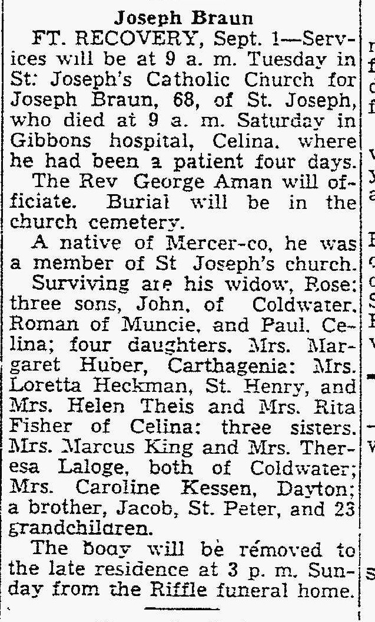
Half-Brother of John M. Braun
The Lima News
2 Sep 1951

