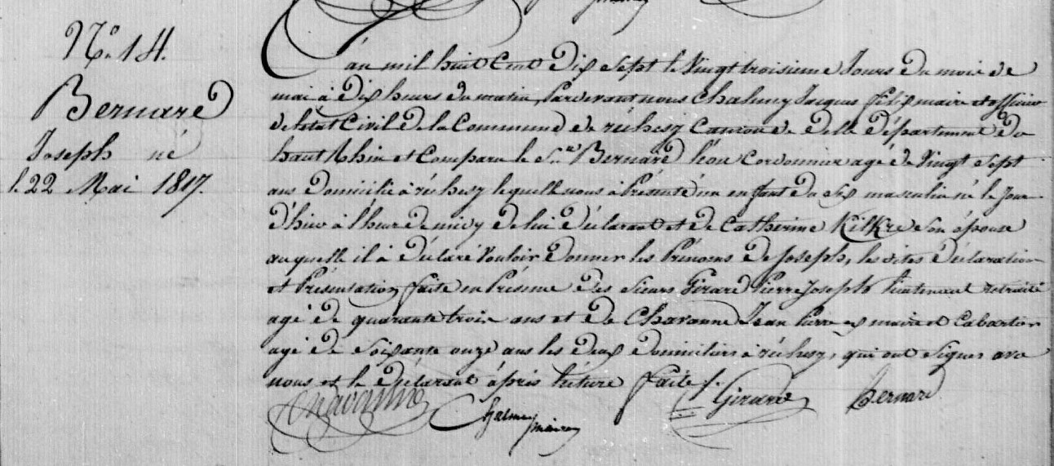
Joseph Bernard Birth Record
Territoire de Belfort, Rechesy
Etat Civil 1 E 81 N.D.M. 1-2
Source: http://www.archives.cg90.fr/ark:/12997/a011341578574HL7fvX/1/1
Image 133/347

