John Wimmers Jr, son of John and Mary Wimmers, brother of Francisca Wimmers
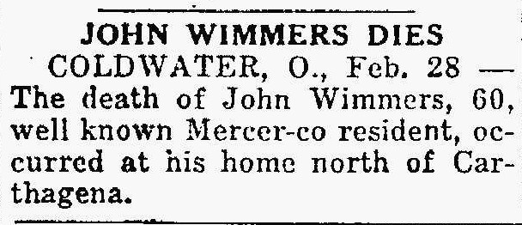
The Lima News, February 28, 1929

