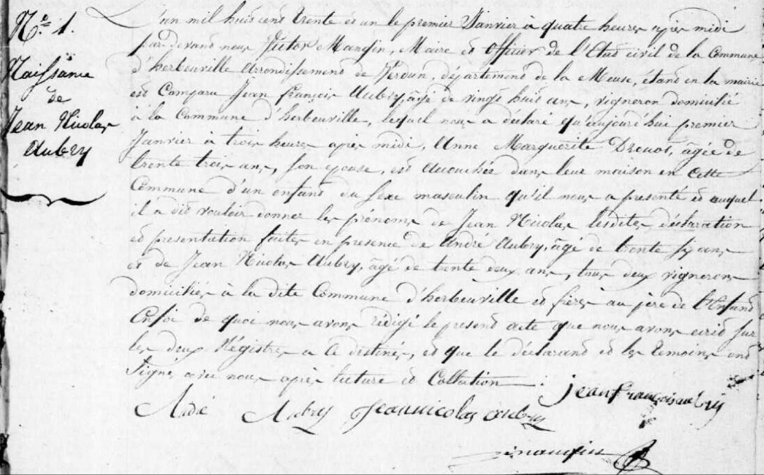
Jean Nicolas Aubry Birth Record, brother of Marie Anne Aubry Grilliot
Source: archives. Meuse.fr
Etat Civil
Herbeuville
1823-1832, Births, Marriages, Deaths
Image 278/353

