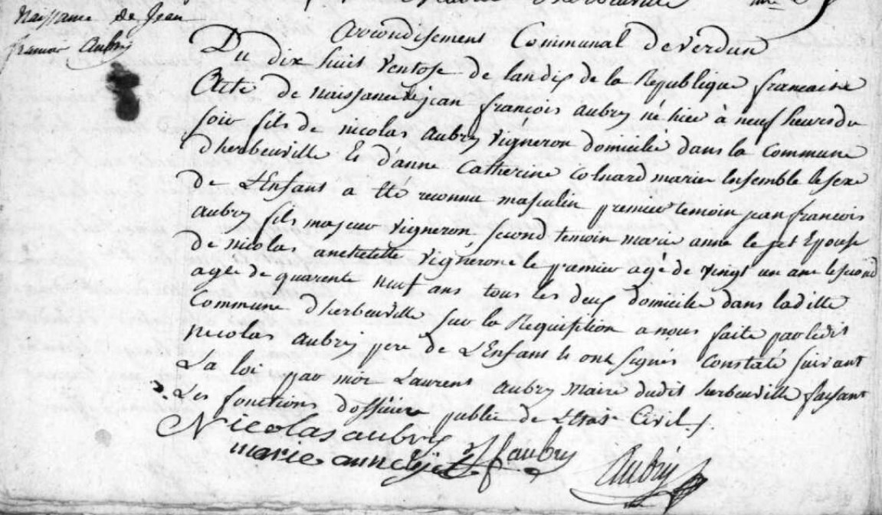
Jean Francois Aubry Birth Record
Source: archives.meuse.fr
Herbeuville
Etat Civil 1792-1802, Births, Marriages, Deaths
Image 227/242

