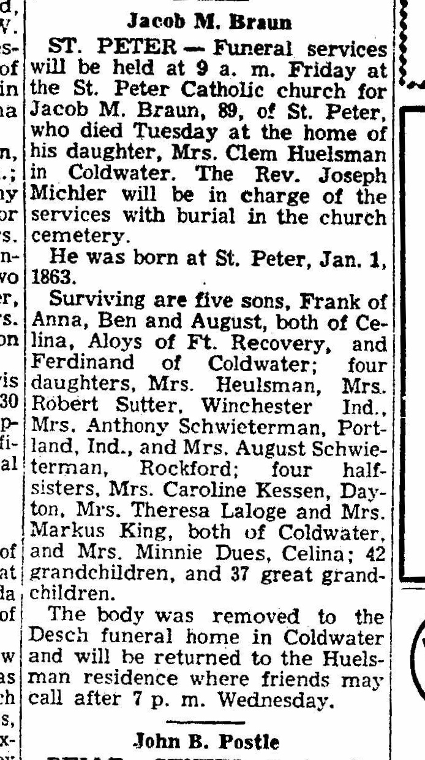
Obituary of Jacob M. Braun, brother of John M. Braun
The Lima News
23 Apr 1952
Page 2, Column 6

