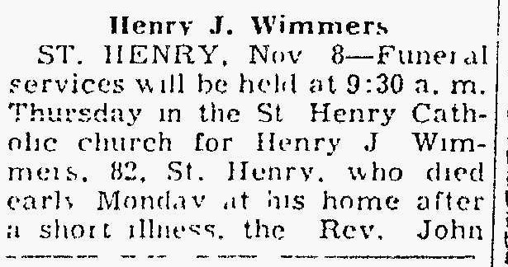
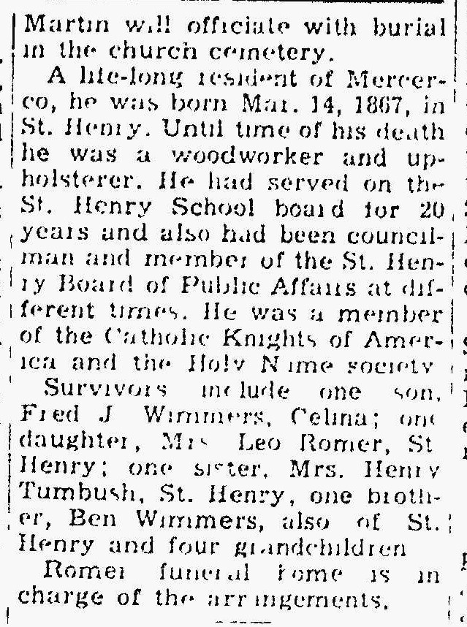

Henry John Wimmers, brother of Frances Wimmers
The Lima News
8 November 1949

