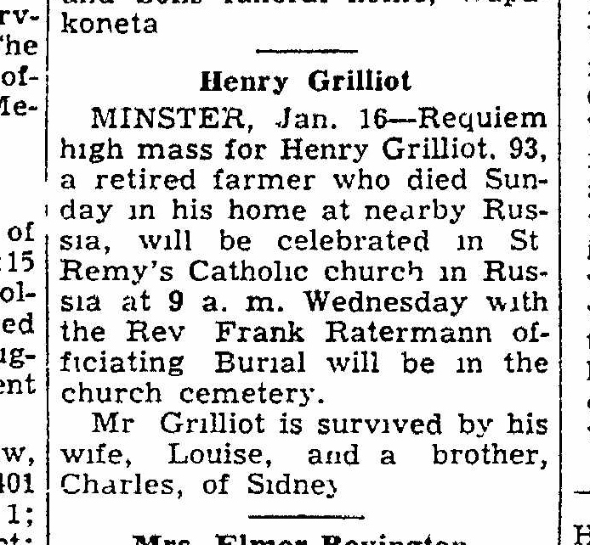
Obituary of Henry Grilliot, brother of Nicholas Grilliot
The Lima News
16 Jan 1951
Page 2, Column 6

