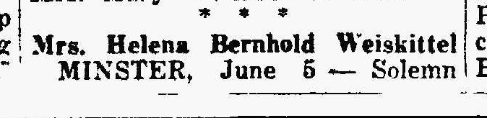
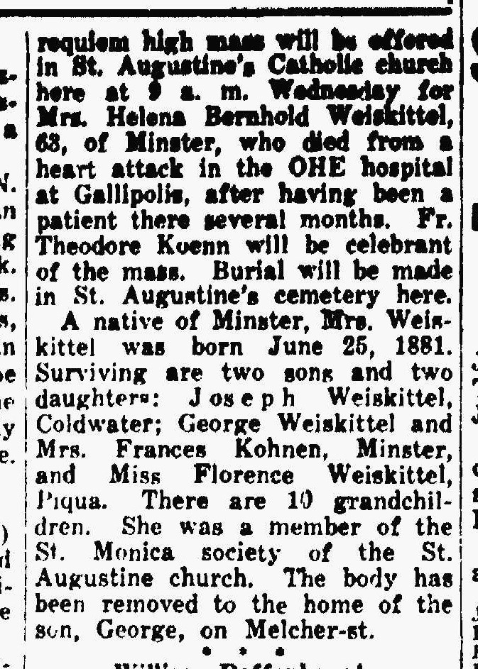
Helena Bernhold Weiskittel, sister of Anna Bernhold Schroeder
The Lima News
5 Jun 1945, page four

