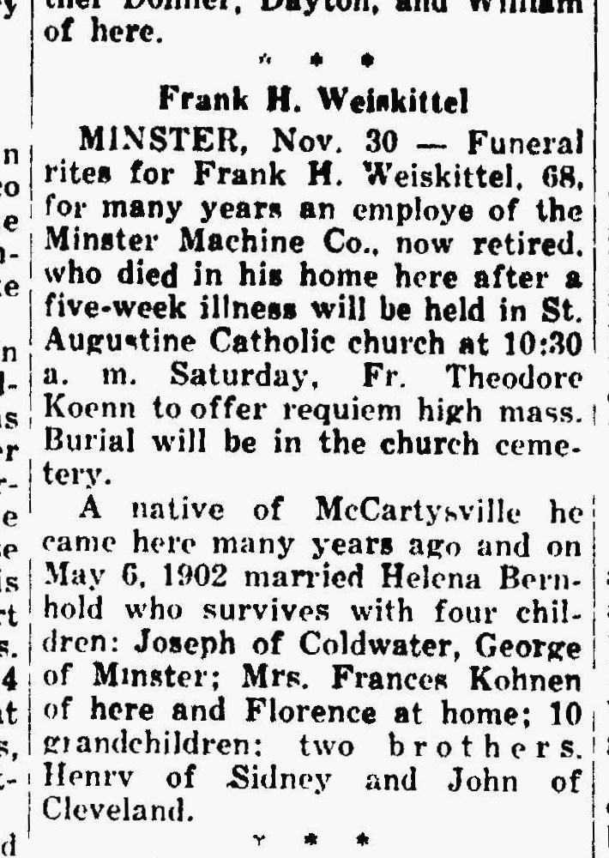
Husband of Helena Bernhold Weiskittel, sister of Anna Bernhold Schroeder
The Lima News
30 Nov 1944

